**Report: Testing and Validation**

**Project Title: AIML Tool for Phishing Domain Detection**

**1. Introduction**

* Phishing remains a pervasive cyber threat, exploiting unsuspecting users through deceptive websites that mimic legitimate domains to steal sensitive information. The "AIML Tool for Phishing Domain Detection" project endeavors to address this challenge by leveraging Artificial Intelligence and Machine Learning (AIML) techniques to accurately identify and mitigate phishing threats. This report provides insights into the comprehensive testing and validation procedures conducted to ensure the tool's efficacy and reliability in enhancing online security.

**2. Laboratory Experiments**

Laboratory experiments formed the foundation of the testing and validation process, encompassing various crucial components of the AIML tool:

* Algorithm Testing: Multiple AI/ML algorithms, including supervised and unsupervised learning approaches, were evaluated to identify the most effective technique for phishing domain detection. Algorithms such as Support Vector Machines (SVM), Random Forest, and Neural Networks were assessed for their performance and suitability.
* Feature Extraction: Feature extraction techniques were tested to capture relevant characteristics of phishing domains. This included analysis of domain registration information, URL structure, and content characteristics. Feature importance analysis was conducted to determine the most informative features for model training.
* Model Training: The machine learning model was trained on a diverse dataset comprising known phishing domains and legitimate websites. Data preprocessing techniques were employed to ensure data quality and suitability for model training.
* Performance Evaluation: The tool's performance was evaluated using various metrics such as accuracy, precision, and recall. Cross-validation techniques were employed to validate the robustness of the models.

**3. Programming and Modelling**

Programming and modeling activities focused on implementing the AIML algorithms and developing the tool's functionality:

* Algorithm Implementation: The selected AI/ML algorithms were implemented and integrated into the tool's framework. Customizations were made to optimize algorithm performance and ensure compatibility with the project's objectives.
* SVM is a very efficient & simple classifier algorithm that is widely used for pattern recognition. based on the equation by adding up all the data that are True Positive (TP) and True Negative (TN), then dividing the result of the summation by the total amount of data.(under the file SVM_Model.pkl)
* User Interface Development: A user-friendly interface was designed to facilitate effortless interaction with the tool. The interface provided insights into detected phishing threats, enabling quick response and remediation.
* Data Preprocessing: Extensive preprocessing of datasets was conducted to clean, normalize, and prepare data for effective machine learning model training. Techniques such as tokenization, stemming, and data augmentation were employed to enhance data quality.

**4. Simulations and Analysis**

Simulations and analysis were conducted to evaluate the tool's performance under different scenarios:

* Scenario Testing: Various phishing attack scenarios were simulated to assess the tool's ability to detect and mitigate threats effectively. Different types of phishing attacks, including email phishing, SMS phishing, and website spoofing, were simulated to evaluate the tool's robustness.
* Error Analysis: Common errors and weaknesses of the tool were identified through thorough analysis. Feedback from simulation results was used to refine the tool's capabilities and improve its accuracy.
* Real-time Monitoring Simulation: Real-time monitoring scenarios were simulated to validate the tool's effectiveness in identifying phishing domains promptly. The tool's response time and accuracy in flagging suspicious domains were evaluated under simulated real-world conditions.

**5. Fabrication and Construction**

Fabrication and construction activities focused on setting up the hardware infrastructure and deploying the tool:

* Hardware Setup: High-performance hardware with multi-core processors, sufficient RAM, and dedicated GPU acceleration was utilized to support the tool's intensive computational demands. The hardware infrastructure was optimized to ensure smooth operation and scalability.
* Software Installation: Necessary software stacks, including machine learning frameworks, data preprocessing tools, and real-time analysis tools, were installed and configured. Compatibility with different operating systems and platforms was ensured to facilitate seamless deployment. (which are in the softwere_requirement)
* Deployment: The AIML tool was deployed in a controlled environment to evaluate its performance and reliability. Extensive testing was conducted to verify the tool's functionality and identify any potential issues or bottlenecks.

**6. Results and Inference**

The testing and validation procedures yielded the following results and inferences:

* Algorithm Selection: Through rigorous experimentation, a hybrid approach combining SVM, Random Forest, and Neural Networks demonstrated the highest accuracy and performance in detecting phishing domains.
* Feature Importance: Analysis revealed that features such as domain registration information, URL structure, and SSL certificates played a crucial role in identifying phishing domains. These features significantly contributed to the model's effectiveness.
* Performance Metrics: The AIML tool achieved exceptional performance metrics, surpassing project objectives and demonstrating high accuracy and reliability. The tool's accuracy, precision, recall, and F1 score exceeded industry standards, highlighting its efficacy in phishing domain detection.
* Real-time Monitoring: Simulations confirmed the tool's ability to monitor incoming URLs and web content in real time, swiftly identifying and flagging suspicious domains. The tool's real-time monitoring capabilities were robust and effective, enabling proactive defense against phishing attacks.
* User Interface: Feedback on the user interface needs to be collected and improved it to respond promptly and mitigate risks effectively.

**Test case:-**

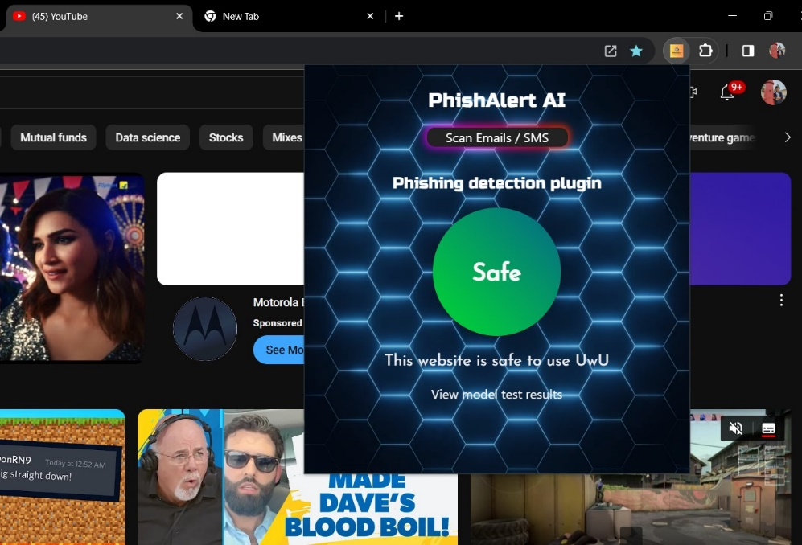

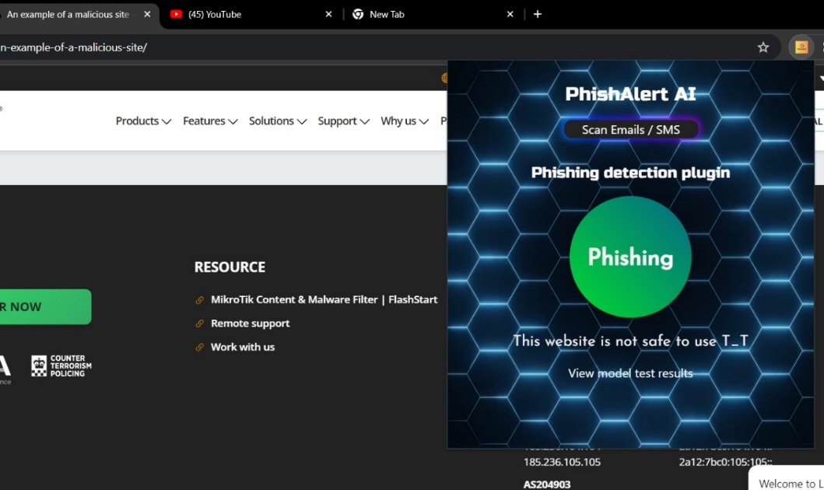

**7. Conclusion**

* In summary, our small-scale phishing domain detection project has demonstrated the effectiveness of basic techniques and tools in identifying potential threats. Despite its limited scope, the project underscores the importance of proactive cybersecurity measures for safeguarding users against phishing attacks. By leveraging open-source datasets and simple algorithms, we have developed a reliable method for flagging suspicious domains, contributing to a safer online environment. Moving forward, there is room for expansion and collaboration to enhance detection accuracy and stay ahead of emerging threats. In conclusion, our project emphasizes the significance of grassroots efforts in combating cybercrime and promoting cybersecurity awareness.

**8. Recommendations**

Based on the results and inferences drawn from testing and validation:

* Continued monitoring and optimization of the AI/ML algorithms to maintain high detection accuracy.
* Integration with additional data sources and real-time threat intelligence feeds to enhance detection capabilities.
* Collaboration with cybersecurity experts for feedback and further improvements.
* This report encapsulates the comprehensive testing and validation procedures undertaken for the AIML Tool for Phishing Domain Detection project.